VIEWS

1. What is Regex?
A regular expression is a sequence of characters that defines a search pattern. It’s used to:
- Find strings in text
- Validate text (like emails, phone numbers)
- Replace or split strings
In Python, regex functionality is provided by the built-in re module.
import re

2. Basic Functions in re
Function | Purpose | Example
re.match() | Checks for a match at the beginning of a string | re.match(r'Hi', 'Hi there') → match
re.search() | Searches anywhere in the string | re.search(r'there', 'Hi there') → match
re.findall() | Returns all occurrences | re.findall(r'\d+', 'I have 2 cats and 3 dogs') → ['2', '3']
re.split() | Splits string by pattern | re.split(r'\s+', 'I am happy') → ['I','am','happy']
re.sub() | Replaces pattern with another string | re.sub(r'\s+', '-', 'I am happy') → 'I-am-happy'

3. Common Regex Symbols
Symbol | Meaning | Example
. | Any character except newline | r'.at' → matches 'cat', 'bat', 'hat'
^ | Start of string | r'^Hello' → matches 'Hello world'
$ | End of string | r'world$' → matches 'Hello world'
* | 0 or more repetitions | r'lo*' → matches 'l', 'lo', 'loo'
+ | 1 or more repetitions | r'lo+' → matches 'lo', 'loo'
? | 0 or 1 repetition | r'lo?' → matches 'l', 'lo'
{n,m} | Between n and m repetitions | r'o{2,3}' → matches 'oo' or 'ooo'
[] | Character set | r'[aeiou]' → matches any vowel
\d | Digit [0-9] | r'\d+' → matches '123'
\w | Word character [a-zA-Z0-9_] | r'\w+' → matches 'Hello123'
\s | Whitespace | r'\s' → matches ' ', '\t', '\n'

DAY1

A URLconf in Django is a Python file that maps website URLs to specific view functions, telling Django which code should run for each URL request.

How Django processes a request

1️⃣ Django first decides which URL configuration (URLconf) to use, usually from ROOT_URLCONF, unless middleware provides a custom one for that request.
2️⃣ It loads that URLconf file and reads urlpatterns, which contains all URL rules created using path() or re_path().
3️⃣ Django checks each URL pattern one-by-one, and stops when it finds the first pattern that matches the requested URL.
4️⃣ The matched view function/class is executed, receiving the HttpRequest and URL parameters; if nothing matches or an error occurs, Django shows an error handler (like 404 or 500).

urls.py in outer or parent directory

from . import views
urlpatterns = [
path("articles/2003/", views.special_case_2003),
path("articles/<int:year>/", views.year_archive),
path("articles/<int:year>/<int:month>/", views.month_archive),
path("articles/<int:year>/<int:month>/<slug:slug>/", views.article_detail),
]

Notes:
- To capture a value from the URL, use angle brackets.
- Captured values can optionally include a converter type. For example, use <int:name> to capture an integer parameter. If a converter isn’t included, any string, excluding a / character, is matched.
- There’s no need to add a leading slash, because every URL has that. For example, it’s articles, not /articles.

Example

. A request to /articles/2005/03/ would match the third entry in the list.
Django would call the function views.month_archive(request, year=2005, month=3).

- /articles/2003/ would match the first pattern in the list, not the second one, because the patterns are tested in order, and the first one is the first test to pass. Feel free to exploit the ordering to insert special cases like this. Here, Django would call the function views.special_case_2003(request)

- /articles/2003 would not match any of these patterns, because each pattern requires that the URL end with a slash.

- /articles/2003/03/building-a-django-site/ would match the final pattern. Django would call the function views.article_detail(request, year=2003, month=3, slug="building-a-django-site").

Path converters
The following path converters are available by default:
str → Matches any non-empty text except / (default converter in Django URLs).
- int → Matches numbers like 1, 25, 100 and passes them to the view as an integer.
- slug → Matches URL-friendly text containing letters, numbers, hyphens (-) and underscores (_) like my-post-1.
- uuid → Matches a valid lowercase UUID with dashes and sends it as a UUID object.
- path → Matches any non-empty string including /, allowing full nested paths.

What is a Custom Converter?
It is a class that tells Django:
a) how to match a URL
b) how to convert URL data before sending it to the view.

1️⃣ regex — What URL is Allowed
regex = "[0-9]{4}"
This tells Django:
Accept only 4 digits in the URL.

2) to_python(self, value)
def to_python(self, value):
return int(value)
✅ Converts URL text → Python datatype.
Example:
URL → /year/2025/
Django sends to view:
year = 2025 # integer
If conversion fails → ValueError → Django returns 404.

3) to_url(self, value)
def to_url(self, value):
return "%04d" % value
✅ Converts Python value → URL string
(used when Django generates URLs using reverse()).

Regest and ye we will study in detail after sometime just wait

What the URLconf searches against:
In Django, URLconf matches only the URL path (like myapp/), ignoring domain name, query parameters (?page=3), and request method (GET/POST).

🚨 Four Error Handlers

1️⃣ handler400
Handles Bad Request (400) errors
👉 Happens when request data is invalid.

2️⃣ handler403
Handles Permission Denied (403)
👉 User is authenticated but not allowed to access.

3️⃣ handler404
Handles Page Not Found (404)
👉 URL does not match any pattern.

4️⃣ handler500
Handles Server Error (500)
👉 Internal error occurs in server/view code

path

path() maps a URL route to a view function or class.

✅ Syntax
path(route, view, kwargs=None, name=None)

kwargs (Optional)
Dictionary used to pass extra arguments to the view.

4name (Optional but VERY Important ⭐)
Gives a unique name to the URL.
Used for:
✅ URL reversing
✅ Templates
✅ Redirects
✅ reverse() function

note ----->

a) inside path in route <int:id> so in views you have to write id as a formal parameter to access it .
b) inside path in dictonay part if you pass any dictionary , you have to write **kwargs to access it .

INCLUDE

include() allows you to divide URLs app-wise instead of putting all URLs in one urls.py.
In include we can give on path or array of path

mysite/
│
├── mysite/
│ └── urls.py ← MAIN URLCONF include yaha pai use krna
│
├── blog/
│ ├── views.py
│ └── urls.py ← BLOG URLs
│
├── shop/
│ ├── views.py
│ └── urls.py ← SHOP URLs

we can use include in two ways :

a) adding file name directly in include :
urlpatterns = [
path('admin/', admin.site.urls),
path('blog/',include(extra_patterns)),
path('shop/',include('shop.urls')),
]

b) extra_patterns = [

path('',home),
path('post/',post)
]
urlpatterns = [
path('admin/', admin.site.urls),
path('blog/',include(extra_patterns)),

we can also add array of path inside include

from django.contrib import admin
from django.urls import path, include

from blog.views import home,post

urlpatterns = [
path('admin/', admin.site.urls),
path('blog/',include([
path("",home),
path('post/',post)
])),
path('shop/',include('shop.urls')),
]

REVERSE URL

Reverse URL resolution means:
Getting the actual URL path using the URL name instead of hardcoding the URL.

a)forward url resolution

url->views->template

b) reverse url resolution

View Name → URL (this view name we define in path name =”something”)

THERE ARE 3 WAY TO DO THIS :

1️⃣ {% url %} Template Tag

Used inside HTML templates.
Example

shop.html

<h1> this is shop page </h1>
<a href="{% url 'shop_detail' 12%}">home</a>

ye jo shop detail hai href mai isko ye search krega urls.py

urlpatterns = [
path('',views.products,name="shop"),
path('cart/',views.cart,{"name":"adarsh"}),
path('<int:id>/',views.product_details,name="shop_detail")
]

2) by using reverse

reverse() is the Python version of {% url %} template tag.

Syntax ---> reverse(viewname, args=None, kwargs=None)
and view name(name that we sepcify in path) is compulsary

✅ Template
{% url 'shop_detail' 12 %}

man lo ye path hai shop/12

✅ Python (views.py)
reverse('shop_detail', args=[12])
Both do the SAME thing.
In views.py if i write inside any view

url = reverse(‘shop_detail’, args=[12]) ----> output is--> /shop/12

mainly using for redirection inside any views

from django.shortcuts import redirect
from django.urls import reverse

def go_to_product(request):

url = reverse("shop_detail", args=[10]) ---> /shop/10

return redirect(url)

3) 3️⃣ get_absolute_url() Method (Models)

Used for model instances.
Very important in professional Django apps.

Idea
Each object knows:
"What is my URL?"

Model Example
from django.urls import reverse
from django.db import models
class Post(models.Model):
title = models.CharField(max_length=100)
def get_absolute_url(self):
return reverse('post_detail', kwargs={'id': self.id})

Now:
post = Post.objects.get(id=5)
post.get_absolute_url() /post/5/

URL NAMESPACE

a URL namespace is used to uniquely identify URLs when multiple apps have the same URL names.

WHY IT IS IMPORTNAT ?

✅ Why URL Namespace is Needed
Suppose two apps exist:
- blog
- shop
Both have:
name="index" IN path
Without namespace ❌
reverse("index") # Django gets confused
Because two URLs have same name.

Maine check kia isko

def app1(request):
url = reverse('index')
print(,url)
return HttpResponse('<h1> This is the page of app1 home </h1>')
def app2(request):
url = reverse('index')
print(url)
return HttpResponse('<h1> This is the page of app2 home </h1>')

both app1 and app2 views gives same url IN PRINT so this is problamatic

solution 1 is :

a) 🔹 Application Namespace

inside urls.py
Defined using:
app_name = "blog"

Identifies the app.

SO NOW IF YOU WANT TO ACCESS IT IN REVERSE YOU HAVE TO WRITE LIKE THIS

def app2(request):
url = reverse('app2:index')
print(url)
return HttpResponse('<h1> This is the page of app2 home </h1>')

and agar template mai ho to write like this

{% url 'app1index' %}

b) instance namespace

Application namespace tells which app,
Instance namespace tells which copy of that app.

✅ Why Instance Namespace Is Needed
Because one app can exist multiple times in the same project.

---> It is defined while using include():
path(
"student/polls/",
include(("polls.urls", "polls"), namespace="student_polls")
)
Here:
- "polls" → application namespace
- "student_polls" → instance namespace

understand by example :( see folder polls)

✅ Step 1 — Create App
polls/
│
├── views.py
└── urls.py

polls/views.py
from django.http import HttpResponse
def index(request):
return HttpResponse("Polls Home Page")

polls/urls.py
from django.urls import path
from . import views
app_name = "polls" # ✅ Application Namespace
urlpatterns = [
path('', views.index, name="index"),
]

project/urls.py
from django.urls import path, include
urlpatterns = [
path(
"student/polls/",
include(("polls.urls", "polls"), namespace="student")
),
path(
"teacher/polls/",
include(("polls.urls", "polls"), namespace="teacher")
),
]

Instance namespace → teacher,student
Application namespace → polls

to include application namespace is important if you access in reverse or template using app_name (‘polls’)
url = reverse('polls:index')
print(url)

but if you are using namespace name, then not important to use app_name in include

url = reverse('student:index')
print(url)

url = reverse('teacher:index')
print(url)

ERROR HANDLING IN VIEW (VIEW2)

HttpResponseNotFound -->
Django ka response hai jo browser ko 404 (Page Not Found) status bhejta hai jab requested page exist nahi karta.

We can also send custom status code :

HttpResponseNotFound(status=201) ,

same you can add in HttpResponse(status=301)

as we know if we are using HttpResponseNotFound() we have to manully define
html , but django provide us inbuilt somehtin to handle 404 error

from django.http import Http404

---> Http404 is not a response it’a an exception so we have to raise it

we can also create custom error handler , using templates

✅ Step 1 — Define One Model

models.py
from django.db import models
class Post(models.Model):
title = models.CharField(max_length=100)
content = models.TextField()
def __str__(self):
return self.title

Run migrations
python manage.py makemigrations
python manage.py migrate

✅ Step 2 — Create View (Force 500 Error)
We intentionally create a server crash.

views.py
from django.shortcuts import render
from .models import Post
def post_view(request):
post = Post.objects.first()
# INTENTIONAL ERROR → causes 500
x = 10 / 0
return render(request, "post.html", {"post": post})
👉 10 / 0 raises:
ZeroDivisionError
Django → triggers 500 Internal Server Error

✅ Step 3 — Custom 500 Error View

views.py (same file)
def custom_server_error(request):
return render(request, "500.html", status=500)

✅ Step 4 — Register handler500
🚨 MUST be inside project urls.py

project/urls.py
from django.contrib import admin
from django.urls import path
from app1 import views
urlpatterns = [
path("admin/", admin.site.urls),
path("post/", views.post_view),
]
handler500 = "app1.views.custom_server_error"

✅ Step 5 — Create 500.html
Folder:
templates/
500.html

500.html
<!DOCTYPE html>
<html>
<head>
<title>Server Error</title>
</head>
<body>
<h1>⚠ Server Error (500)</h1>
<p>Something went wrong on our side.</p>
<a href="/">Go Home</a>
</body>
</html>

✅ Step 6 — IMPORTANT SETTING
Custom 500 works ONLY when:

settings.py
DEBUG = False
AND
ALLOWED_HOSTS = ["*"]

same like handler 500 we have something more

The page_not_found() view is overridden by handler404:
handler404 = "mysite.views.my_custom_page_not_found_view"
The server_error() view is overridden by handler500:
handler500 = "mysite.views.my_custom_error_view"
The permission_denied() view is overridden by handler403:
handler403 = "mysite.views.my_custom_permission_denied_view"
The bad_request() view is overridden by handler400:
handler400 = "mysite.views.my_custom_bad_request_view
SOME FUNCTION THAT WE USE INSIDE VIEWS

a) render()
render(request, template_name, context=None, content_type=None, status=None, using=None)[source]¶
required arguments are request and template
b) redirect()¶
redirect(to, *args, permanent=False, preserve_request=False, **kwargs)[source]¶
Returns an HttpResponseRedirect to the appropriate URL for the arguments passed.
The arguments could be:
- A model: the model’s get_absolute_url() function will be called.
- A view name, possibly with arguments: reverse() will be used to reverse-resolve the name.

✅ Method 1 — Redirect using URL
return redirect("/home/")

✅ Method 2 — Redirect using View Name ✅ BEST
return redirect("post-detail", id=1)
Django internally uses:
reverse()
And agr url mai app_name use kia hai so also specify it here :redirect("app1:post-detail", id=1)

render() → show page
redirect() → move user
get_object_or_404() → safe DB fetch
get_list_or_404() → safe list fetch
resolve_url() → normalize URL

VIEW DECORATORS

View decorators¶
Django provides several decorators that can be applied to views to support various HTTP features.
See Decorating the class for how to use these decorators with class-based views.

Allowed HTTP methods¶
The decorators in django.views.decorators.http can be used to restrict access to views based on the request method. These decorators will return a django.http.HttpResponseNotAllowed if the conditions are not met.
require_http_methods(request_method_list)[source]¶
Decorator to require that a view only accepts particular request methods. Usage:
from django.views.decorators.http import require_http_methods

@require_http_methods(["GET", "POST"])
def my_view(request):
# I can assume now that only GET or POST requests make it this far
# ...
pass
Note that request methods should be in uppercase.
require_GET()¶
Decorator to require that a view only accepts the GET method.
require_POST()¶
Decorator to require that a view only accepts the POST method.

Conditional view processing¶
The following decorators in django.views.decorators.http can be used to control caching behavior on particular views.
condition(etag_func=None, last_modified_func=None)[source]¶
conditional_page()¶
This decorator provides the conditional GET operation handling of ConditionalGetMiddleware to a view.
etag(etag_func)[source]¶
last_modified(last_modified_func)[source]¶
These decorators can be used to generate ETag and Last-Modified headers; see conditional view processing.

GZip compression¶
The decorators in django.views.decorators.gzip control content compression on a per-view basis.

Vary headers¶
The decorators in django.views.decorators.vary can be used to control caching based on specific request headers.

Caching¶
The decorators in django.views.decorators.cache control server and client-side caching.

How Django serves media (uploaded) files during development.

✅ 1. Problem: Why do we need this?
In Django, there are two types of files:
Type | Example | Stored In
Static files | CSS, JS, Images | STATIC_ROOT
Media files | User uploads (profile pic, pdf) | MEDIA_ROOT

Example:
- User uploads profile image
- Django stores it inside MEDIA_ROOT
👉 But Django does NOT automatically serve media files.
So when you open
http://127.0.0.1:8000/media/profile.jpg
❌ Django cannot show the file unless we configure it.

✅ 2. Django Solution → serve() View
Django provides a built-in view:
django.views.static.serve
This view:
- Reads files from a folder
- Sends them to the browser
⚠️ Only for development

✅ 3. Important Settings
In settings.py:
MEDIA_URL = '/media/'
MEDIA_ROOT = BASE_DIR / 'media'

serve() is a Django development view used to serve user-uploaded media files from MEDIA_ROOT using MEDIA_URL during development only.
Note --> always store media inside root not inside apps

ERRORS IN VIEW

✅ What Are Error Views in Django?
When something goes wrong in Django:
- Page not found ❌
- Permission denied ❌
- Server crashes ❌
- Bad request ❌
Django automatically shows error pages.
These are called 👉 Error Views.
Django provides 4 default error views:
Error | Meaning
404 | Page Not Found
500 | Server Error
403 | Permission Denied
400 | Bad Request

✅ 1️⃣ 404 Error — Page Not Found

When does 404 happen?

Case 1:
URL does not exist.
Example:
http://127.0.0.1:8000/abc/
But no URL matches → ❌

Case 2:
You manually raise error:
from django.http import Http404
def myview(request):
raise Http404("Page not found")

What Django does internally?
Django calls:
django.views.defaults.page_not_found

Template Used
Django searches:
templates/404.html
If exists ✅ → show it
Else ❌ → shows default "Not Found"

Variables Passed to Template
Inside 404.html you get:
Variable | Meaning
request_path | URL causing error
exception | error message
Example:
<h1>Page {{ request_path }} not found</h1>

⚠ IMPORTANT
If:
DEBUG = True
👉 Custom 404 page will NOT show
👉 Django debug page appears instead.

✅ 2️⃣ 500 Error — Server Error

When does it occur?
When your view crashes.
Example:
def home(request):
x = 10 / 0 # crash
💥 Runtime Exception occurs.

Django calls:
django.views.defaults.server_error

Template Used
templates/500.html

Important Point ⭐
❌ No variables passed to template.
Why?
Because server already crashed — passing data may cause more errors.

DEBUG Behavior
DEBUG | Result
True | Full traceback shown
False | 500.html shown

✅ 3️⃣ 403 Error — Permission Denied

Meaning:
User exists but not allowed.
Example:
- Normal user accessing admin page.

How to trigger?
from django.core.exceptions import PermissionDenied
def edit(request):
if not request.user.is_staff:
raise PermissionDenied

Django calls:
django.views.defaults.permission_denied

Template Used
templates/403.html

Template Variable
Variable | Meaning
exception | reason for denial
Example:
<h1>Access Denied</h1>
<p>{{ exception }}</p>

✅ 4️⃣ 400 Error — Bad Request

When does this happen?
When request is invalid or suspicious.
Example:
- Corrupted cookies
- Invalid headers
- Security issue
Django raises:
SuspiciousOperation

Then Django calls:
django.views.defaults.bad_request

Template Used
templates/400.html

Important Security Rule ⭐
❌ Exception details are NOT passed.
Reason:
Sensitive info like:
- file paths
- system info
must not leak.

DEBUG Behavior
400 page works only when:
DEBUG = False

✅ COMPLETE FLOW DIAGRAM
User Request
↓
Something Wrong Happens
↓
Django detects error type
↓
Calls default error view
↓
Loads 400 / 403 / 404 / 500 template
↓
Shows error page

✅ SUPER IMPORTANT INTERVIEW POINT ⭐⭐⭐
Custom error pages work only when:
DEBUG = False

✅ Folder Structure (Best Practice)
project/
templates/
404.html
500.html
403.html
400.html
No URL mapping needed ✅
Django auto-detects them.

✅ One-Line Memory Trick 🧠
404 → page missing
403 → permission denied
500 → server crash
400 → bad request

Django Request–Response

Step Flow
- User sends request
- Django creates HttpRequest object
- Django calls your view
- View returns HttpResponse
- Browser receives response

def home(request):
return HttpResponse("Hello")
👉 request = incoming data
👉 HttpResponse = outgoing data
ALL ABOUT REQUEST
our request contain all the data about user request :
a) methods --> get,put , post,delete,
ex--> request.method --> this give you method name
b) request.POST ---> return dictioary that include all key value pair of data come from form
name = request.POST['name']
c) ✅ (4) request.FILES
Used for uploaded files.
file = request.FILES['image']
Works only when:
<form enctype="multipart/form-data">

✅ (5) request.path
Requested URL path.
print(request.path)
Output:
/products/12/

✅ (6) request.headers----> return dictionay of all headers
All browser headers.
request.headers["User-Agent"]
Example:
Chrome browser info

✅ (7) request.user
(Current logged-in user)
if request.user.is_authenticated:
print("Logged in")
Provided by:
✅ AuthenticationMiddleware

✅ (8) request.COOKIES
Browser cookies.
request.COOKIES['username']

✅ (9) request.META
Low-level request info.
Example:
request.META['REMOTE_ADDR']

ALL ABOUT HTTP RESPONSE OBJECT
from django.http import HttpResponse
def home(request):
return HttpResponse("Hello World")

✅ String Response
HttpResponse("Hello")

✅ Add Content Later
response = HttpResponse()
response.write("<h1>Hello</h1>")
return response

✅ Set Status Code
HttpResponse("Not found", status=404)

✅ Add Headers
response["Age"] = 120

✅ 5. Cookies in Response
Set cookie:
response.set_cookie("username", "adarsh")
Delete cookie:
response.delete_cookie("username")

✅ 6. Important HttpResponse Subclasses
Django gives ready responses.

✅ Redirect
from django.http import HttpResponseRedirect
return HttpResponseRedirect("/home/")
Status:
302

✅ 404 Response
from django.http import HttpResponseNotFound
return HttpResponseNotFound("Page not found")

✅ 403 Forbidden
HttpResponseForbidden()

✅ 500 Server Error
HttpResponseServerError()

✅ 7. JsonResponse (VERY IMPORTANT 🚀)
Used in APIs.
from django.http import JsonResponse
def api(request):
return JsonResponse({"name": "Adarsh"})

✅ 8. StreamingHttpResponse (Large Data)
Used when data is huge.
Example:
- Large CSV
- Video streaming
- Live data
StreamingHttpResponse(generator())
It sends data piece by piece.

✅ 9. FileResponse
Best for file download.
from django.http import FileResponse
return FileResponse(open("file.pdf","rb"))

TemplateResponse objects

✅ 1️⃣ Problem With Normal HttpResponse
Normally you write:
return render(request, "home.html", context)
Internally Django does:
Template + Context
↓
Rendered HTML
↓
HttpResponse(HTML)
👉 HTML is created immediately.
So response becomes static.
After this:
❌ middleware
❌ decorators
cannot easily modify template or context.

✅ 2️⃣ Why TemplateResponse Exists
Sometimes Django wants:
✅ modify template later
✅ modify context later
✅ apply caching
✅ middleware processing
So Django delays rendering.
This is called:
Lazy Rendering (Deferred Rendering)

✅ Core Idea ⭐⭐⭐
HttpResponse → rendered immediately
TemplateResponse → rendered later

3️⃣ SimpleTemplateResponse:
This is the base class.
It stores:
✅ template name
✅ context
✅ rendering info
BUT does NOT render immediately

Creation
from django.template.response import SimpleTemplateResponse
response = SimpleTemplateResponse(
"home.html",
{"name": "Adarsh"}
)
At this moment:
HTML NOT GENERATED ❌
Only data stored.

Important Attributes

✅ template_name
Template to render.
response.template_name
Example:
"home.html"
or
["a.html", "b.html"]
(first available loads)

✅ context_data
Template data.
response.context_data
Example:
{"foo":123}

✅ rendered_content
Final HTML after rendering.
response.rendered_content

✅ is_rendered
Checks rendering status.
response.is_rendered
Output:
False → not rendered
True → rendered

4️⃣ Rendering Process

Rendering happens ONLY when needed.
It occurs in 3 situations:

✅ Case 1 — Manual render()
response.render()
Now HTML generated.

✅ Case 2 — Accessing content
response.content ---> it consist your html , so if you pass it in httpresponse you get all html
Django auto renders.

If you direct return response you also get that same response

FILES
When Django handles a file upload, the file data ends up placed in request.FILES

CLASS BASED VIEW

1. What are Basic Generic Views?
Django already provides ready-made view classes so you don’t need to write common logic again and again.
Instead of writing:
def about(request):
return render(request, "about.html")
Django gives prebuilt classes.
All these views come from:
django.views.generic

✅ 2. Base Class → View
👉 Every class-based view inherits from:
django.views.generic.base.View
This class handles:
- URL connection
- HTTP method checking (GET, POST)
- Request dispatching
Example internally:
GET request → get()
POST request → post()
So Django automatically decides which method to run.

✅ 3. TemplateView
This is the most commonly used generic view.
👉 Purpose:
Render a template without writing a function view.
Instead of:
def about(request):
return render(request,"about.html")
You can write:
TemplateView

✅ 4. Using Generic View in URLconf
Your example:
from django.urls import path
from django.views.generic import TemplateView
urlpatterns = [
path("about/", TemplateView.as_view(template_name="about.html")),
]
Now understand line by line.

✅ Step 1 — Import
from django.views.generic import TemplateView
Import Django’s ready-made template rendering view.

✅ Step 2 — TemplateView.as_view()
⚡ VERY IMPORTANT
Class-based views cannot be used directly.
❌ Wrong:
TemplateView()
✅ Correct:
TemplateView.as_view()
👉 as_view() converts the class into a callable view function.

✅ Step 3 — Passing Attributes
TemplateView.as_view(template_name="about.html")
Here you are setting:
template_name = "about.html"
without creating a new class.
So Django internally behaves like:
class AboutView(TemplateView):
template_name = "about.html"

✅ 5. Final Flow
User visits:
/about/
⬇
URL matches
⬇
TemplateView.as_view()
⬇
GET request detected
⬇
Template rendered
⬇
about.html shown

✅ 6. Important Line From Docs
Any arguments passed to as_view() will override attributes set on the class.
Meaning:
If class already has attributes, you can change them directly in URL.
Example:
path(
"about/",
TemplateView.as_view(template_name="new_about.html")
)
This overrides default template.

Example 1 — Class Default Template
class AboutView(TemplateView):
template_name = "about.html"

Example 2 — Override from URL
path(
"about/",
AboutView.as_view(template_name="new_about.html")
)
Now Django does internally:
template_name = "new_about.html"
✅ Old value replaced
✅ New template used

✅ 7. Another Generic View Mentioned → RedirectView
Used when you want automatic redirect.
Example:
from django.views.generic import RedirectView
path(
"google/",
RedirectView.as_view(url="https://google.com")
)
Visiting /google/ redirects user.

UNDERSTAND MAJOR CLASS BASED VIEWS
check class folder
⭐ ListView
⭐ DetailView
⭐ CreateView
⭐ UpdateView
⭐ DeleteView
⭐ FormView

A) ListView

✅ Step 0 — Model (Common for ALL Views)

models.py
from django.db import models
class Book(models.Model):
title = models.CharField(max_length=100)
author = models.CharField(max_length=100)
price = models.IntegerField()
def __str__(self):
return self.title

⭐ 1. ListView (Show All Books)
👉 Used when you want to display multiple objects
Example:
📚 Show all books in library

views.py
from django.views.generic import ListView
from .models import Book
class BookListView(ListView):
model = Book // internally Book.objects.all() call krta hai
template_name = "books/book_list.html"
context_object_name = "books" aapke template data books name se access ho jayegi

urls.py
path("books/", BookListView.as_view(), name="book-list")

template → book_list.html
<h2>All Books</h2>
{% for book in books %}
<p>
{{ book.title }} -
{{ book.author }} -
₹{{ book.price }}
</p>
{% endfor %}
✅ Output → List of all books

⭐ 2. DetailView (Single Book Detail)
👉 Shows one object
Example:
📖 Click book → see details

views.py
from django.views.generic import DetailView
class BookDetailView(DetailView):
model = Book
template_name = "books/book_detail.html"
context_object_name = "book"

urls.py
path("books/<int:pk>/",
BookDetailView.as_view(),
name="book-detail")

template
<h2>{{ book.title }}</h2>
<p>Author : {{ book.author }}</p>
<p>Price : ₹{{ book.price }}</p>
✅ Django automatically fetches object using pk

⭐ 3. CreateView (Add New Book)
👉 Create new database record
Example:
➕ Add Book Form

views.py
from django.views.generic import CreateView
from django.urls import reverse_lazy
class BookCreateView(CreateView):
model = Book
fields = ["title", "author", "price"]
template_name = "books/book_form.html"
success_url = reverse_lazy("book-list")

Here success_url means whent you created the data after that where do you want to redirect
that why here we use succeess_url ,
but one questoin , why didn’t i used reverse on the place of reverse_lazy , --> because reverse turant call kr dega us url ko but problem is jo data create ho reha hai usme time lagage na that’s why we use here reverse_lazy
reverse_lazy() delays URL resolution until runtime, preventing errors when URLs are not yet loaded in class-based views.

urls.py
path("books/add/",
BookCreateView.as_view(),
name="book-add")

template
<h2>Add Book</h2>
<form method="post">
{% csrf_token %}
{{ form.as_p }}
<button type="submit">Save</button>
</form>
✅ Django automatically:
- creates form
- validates data
- saves object
form.as_p automatically displays all form fields inside paragraph (<p>) tags.

⭐ 4. UpdateView (Edit Book)
👉 Update existing object
Example:
✏ Edit Book

views.py
from django.views.generic import UpdateView
class BookUpdateView(UpdateView):
model = Book
fields = ["title", "author", "price"]
template_name = "books/book_form.html"
success_url = reverse_lazy("book-list")

urls.py
path("books/<int:pk>/edit/",
BookUpdateView.as_view(),
name="book-update")

✅ Same form reused
✅ Existing data auto-filled

⭐ 5. DeleteView (Delete Book)
👉 Delete object safely
Example:
🗑 Remove Book

views.py
from django.views.generic import DeleteView
class BookDeleteView(DeleteView):
model = Book
template_name = "books/book_confirm_delete.html"
success_url = reverse_lazy("book-list")

urls.py
path("books/<int:pk>/delete/",
BookDeleteView.as_view(),
name="book-delete")

template
<h3>Are you sure?</h3>
<p>{{ object.title }}</p>
<form method="post">
{% csrf_token %}
<button type="submit">Delete</button>
</form>
✅ Prevents accidental deletion
✅ object = the model instance that Django automatically sends to template

5. What is FormView?

In Django, forms typically follow three main stages:
- Initial GET Request: Display a blank or prepopulated form.
- POST with Invalid Data: Re-render the form with validation errors.
- POST with Valid Data: Process the data and usually redirect to a success page.

1. FormView (Core Concept)

✅ Step 1 — Create Form

📁 forms.py
from django import forms
class ContactForm(forms.Form):
name = forms.CharField(max_length=100)
email = forms.EmailField()
message = forms.CharField(widget=forms.Textarea)
def send_email(self):
print("Email sent to admin")

✅ Step 2 — Create View

📁 views.py
from django.views.generic.edit import FormView
from .forms import ContactForm
class ContactFormView(FormView):
template_name = "contact.html"
form_class = ContactForm
success_url = "/thanks/"
def form_valid(self, form):
form.send_email() // it call your method that you define in form
return super().form_valid(form) // here if form is valid then success url hit

✅ Step 3 — URL

📁 urls.py
from django.urls import path
from .views import ContactFormView
urlpatterns = [
path("contact/", ContactFormView.as_view(), name="contact"),
]

✅ Step 4 — Template

📁 templates/contact.html
<h2>Contact Form</h2>
<form method="post">
{% csrf_token %}
{{ form.as_p }}
<button type="submit">Send</button>
</form>

Now understand form in detail in form part

some important thing about form
models.py
class Author(models.Model):
name = models.CharField(max_length=200)
created_by = models.ForeignKey(User, on_delete=models.CASCADE)
def get_absolute_url(self):
print("zerp")
return reverse("author-detail", kwargs={"pk": self.pk})

views.py

from .models import Author
from django.urls import reverse_lazy
from django.views.generic.edit import CreateView, DeleteView, UpdateView
from app1.models import Author
from django.http import HttpResponse

class AuthorCreateView(CreateView):
model = Author
fields = ["name"]

class AuthorUpdateView(UpdateView):
model = Author
fields = ["name"]

class AuthorDeleteView(DeleteView):
model = Author
success_url = reverse_lazy("author-list")

from django.contrib.auth.mixins import LoginRequiredMixin

class AuthorCreateView(LoginRequiredMixin, CreateView):
model = Author
fields = ["name"]

def form_valid(self, form):
print(form.instance)
print(self.request.user.id)
form.instance.created_by = self.request.user
return super().form_valid(form)
def printView(req,pk):
return HttpResponse("FDafsasffdsa")

urls.py

from django.urls import path
from app1.views import AuthorCreateView, AuthorDeleteView, AuthorUpdateView,printView

urlpatterns = [
# ...
path("author/add/", AuthorCreateView.as_view(), name="author-add"),
path("author/<int:pk>/", AuthorUpdateView.as_view(), name="author-update"),
path("author/<int:pk>/delete/", AuthorDeleteView.as_view(), name="author-delete"),
path("author/detail/<int:pk>",printView,name="author-detail")
]

author_form.html
<h2>Add Author</h2>

<form method="post">
{% csrf_token %}
{{ form.as_p }}

<button type="submit">
Save
</button>
</form>
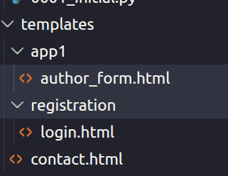

login.html

<h2>Login</h2>

<form method="post">
{% csrf_token %}
{{ form.as_p }}

<button type="submit">Login</button>
</form>

now understnad the flow

a) your hit url author/add
b) if your are not login , it will redirect you on login page
c) after that you go on author/add page
d) when you sumit that form that is in author.form.html it will go to def form_valid in views.py of that author/add route view
e) after this it will go to model get_absolute_url and then you wil go to page that mention in get_absolute url
MIDDELWARE IN DJANGO

a) middelware is a framework of hooks into djanog request/response processing
b) it is a light low level plugin system for globally altering django input or output .

There are two types of miidelware
a) built in middelware
b) custom middelware

HOW MIDDELWARE WORKS

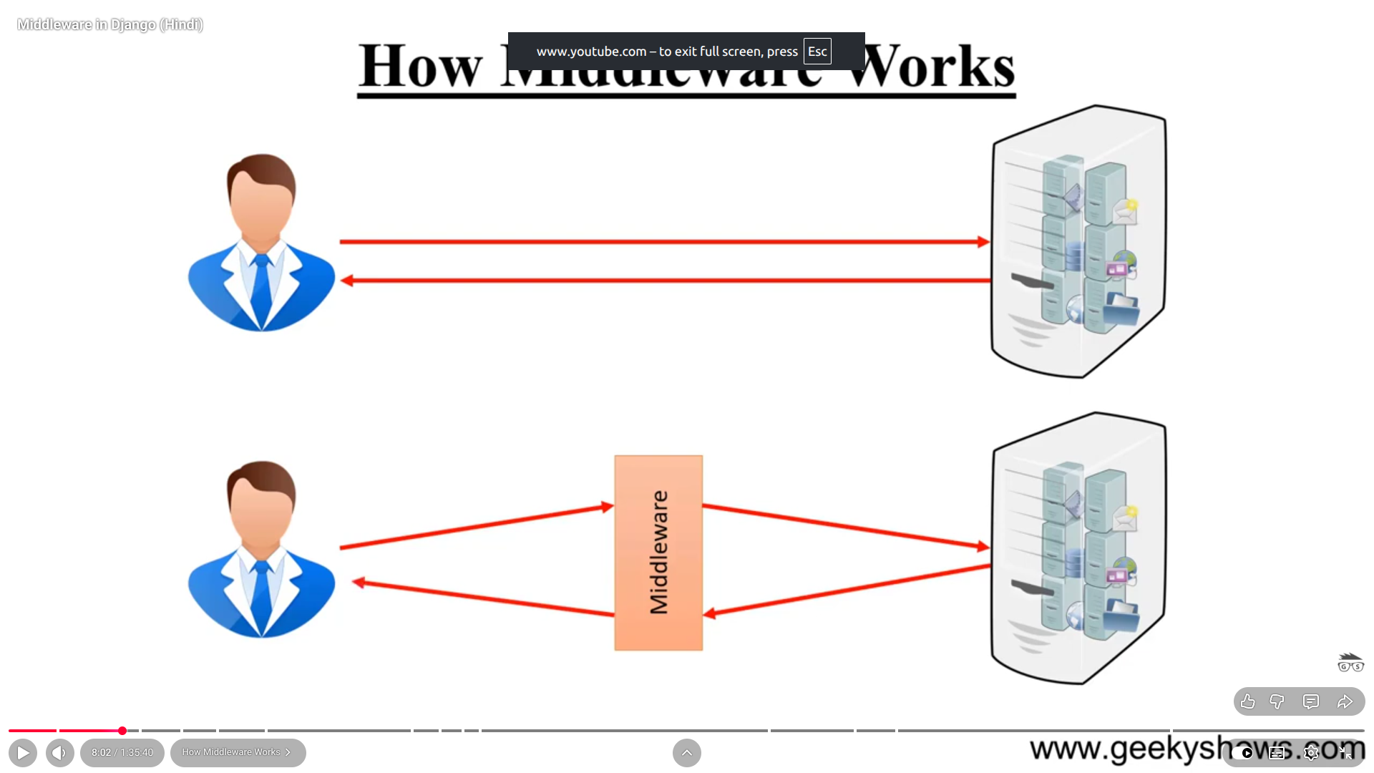
JHGK

NOW WE UNDERSTAND HOW TO MAKE MIDDELWARE AND USED IT

A) FUNCTION BASED MIDDELWATE

--> a middelware factory is a callable that takes a get_response callable and return a middelware .

def my_middelware(get_response):
# one time configuration and initialization
def my_function(request):
# code to be executed for each request before the view are called
response = get_response(request)
# code to be executed for each request/response after the view is called
return response
return my_function

get_response()

The get_response callable provided by django might be the actual view (if this is the last listed middelware) or it might be the next middelware in the chain, and us chain mai koi view ho to wo ho jayega
The current middelware doesn’t need to know or care what exactly it is ,just that it represents whatever comes next

The get_response callable for the last middelware in the chain won’t be the acutal view but rather a wrapper method from the handler which takes care of applying view middelware, calling the view with appropriate url arguments , and applying template response and exception middelware

How to activate middelware

to activate middelware add it in MIDDELWARE IN SETTING.PY
in middelware , each middelware componenent is a string , :The full python path to the middelwarre factory’s class or function name.The order in middelware matters because a middelware can depend on the other middelware for instnace authentication middelware sotres the authenticated user in the session ; therefor it must run after session middelware

ex MIDDELWARE = [

‘blog.middelwares.my_middelware’
app_name.folder_name.file_name
]

HOW TO MAKE function BASED MIDDELWARE (gs91)
YOU HAVE TO CREATE FILE IN SAME APPLICATION middlewares.py

middlewares.py
def my_middleware(get_response):
print("One time intialization")
so this is one time intialization , when server load first time
def my_function(req):
print("This is befor view")
response = get_response(req)
print("This is after view")
return response
return my_function

now add this in middlewares in setting.py
'blog.middlewares.my_middleware',

now make one views.py
def home(req):
print("this is my view")
return HttpResponse("This is home page")

now see the output in console

his is befor view
this is my view
This is after view

HOW TO MAKE FUNCTION BASED MIDDLEWARE (gs92)

class MyMiddleware:
def __init__(self,get_response):
self.get_response = get_response
# one time initialization and configuration
def __call__(self,request):
# code to be executed for each request before the view (and later middelware) are called .
response = self.get_response(request)
# code to be executed for each request/response after the view is called
return response

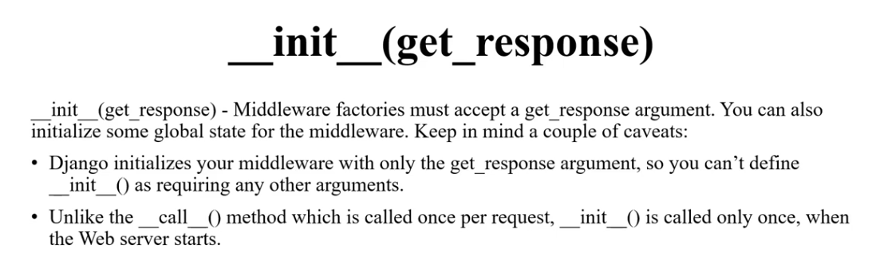

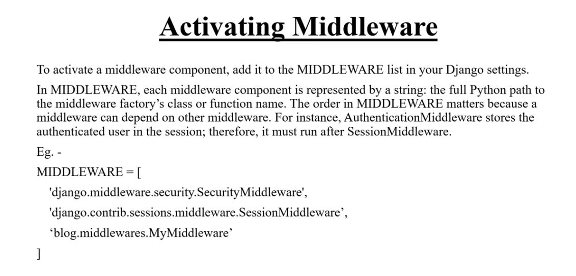

middlewares .py

# * how to make class based middelware

class MyMiddleware:
def __init__(self,get_response):
self.get_resposne = get_response
print("one time initialization")

def __call__(self,request):
print("this is before view ")
response = self.get_resposne(request)
print("this is after view")
return response

now we understand how to make one or more middelwares (gs93)

same blog application i copy of gs92 just add this middelwares

# def my_middleware(get_response):
# print("One time intialization")

# def my_function(req):
# print("This is befor view")
# response = get_response(req)
# print("This is after view")
# return response
# return my_function

# * how to make class based middelware

class BrotherMyMiddleware:
def __init__(self,get_response):
self.get_resposne = get_response
print("one time Brother initialization")

def __call__(self,request):
print("this is brother before view ")
response = self.get_resposne(request)
print("this is brother after view")
return response

class FatherMyMiddleware:
def __init__(self,get_response):
self.get_response = get_response
print("one time father initialization")

def __call__(self,request):
print("this is father befor view")
response = self.get_response(request)
print("This is Father after view")
return response

class MotherMyMiddleware:
def __init__(self,get_response):
self.get_response = get_response
print("one time Mother initialization")

def __call__(self,request):
print("this is mother before view")
response = self.get_response(request)
print("This is mother after view")
return response

MIDDLEWARE = [
'django.middleware.security.SecurityMiddleware',
'django.contrib.sessions.middleware.SessionMiddleware',
'django.middleware.common.CommonMiddleware',
'django.middleware.csrf.CsrfViewMiddleware',
'django.contrib.auth.middleware.AuthenticationMiddleware',
'django.contrib.messages.middleware.MessageMiddleware',
'django.middleware.clickjacking.XFrameOptionsMiddleware',
'blog.middlewares.BrotherMyMiddleware',
'blog.middlewares.FatherMyMiddleware',
'blog.middlewares.MotherMyMiddleware'
]

now if you see the order of execution that is :

one time Mother initialization
one time father initialization
one time Brother initialization

this is brother before view
this is father befor view
this is mother before view

this is my view
This is mother after view
This is Father after view
this is brother after view
bro aisa output aaya because get_response ka matlab hota hai , agar next middelware hai to uspe jao warna view pai , and hmre paas 3 middelware thai and tino ke pass get_resposne tha
response = self.get_response(request)

but if you want ki aisa na ho to write :
class FatherMyMiddleware:
def __init__(self,get_response):
self.get_response = get_response
print("one time father initialization")

def __call__(self,request):
print("this is father befor view")
response = HttpResponse("nikl lo yaha se ")
print("This is Father after view")
return response

see inside father i wrote inside call HttpResponse so,i get this output on webpage
this is brother before view
this is father befor view
This is Father after view
this is brother after view

aab dekho mother middelware chala bhi nahi , because maine father se hi direct response send kr dia

MIDDLEWARE HOOKS (gs94)
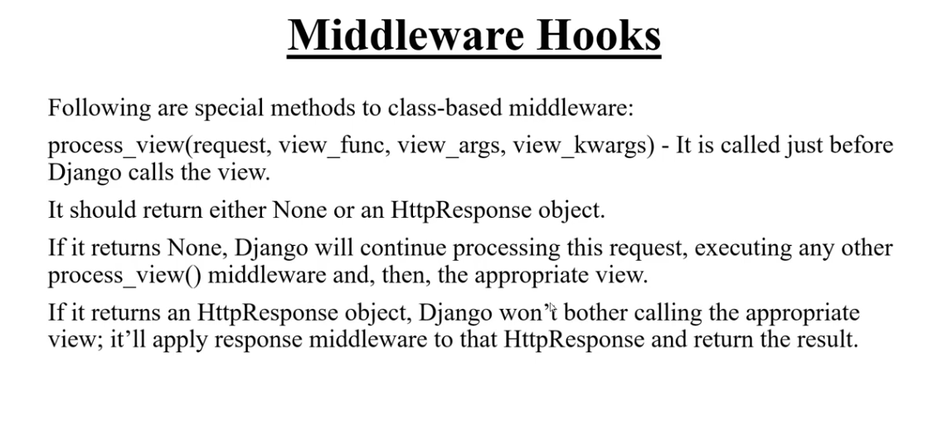
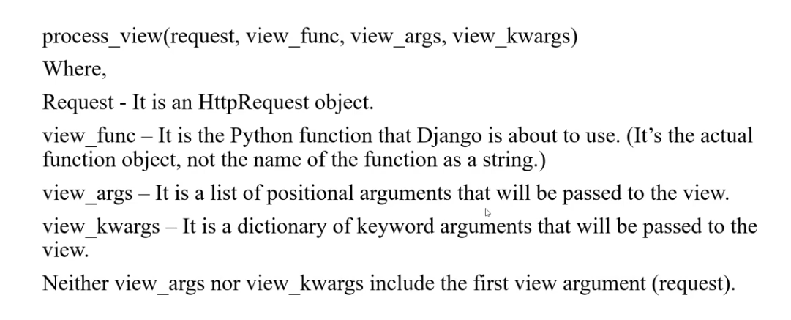
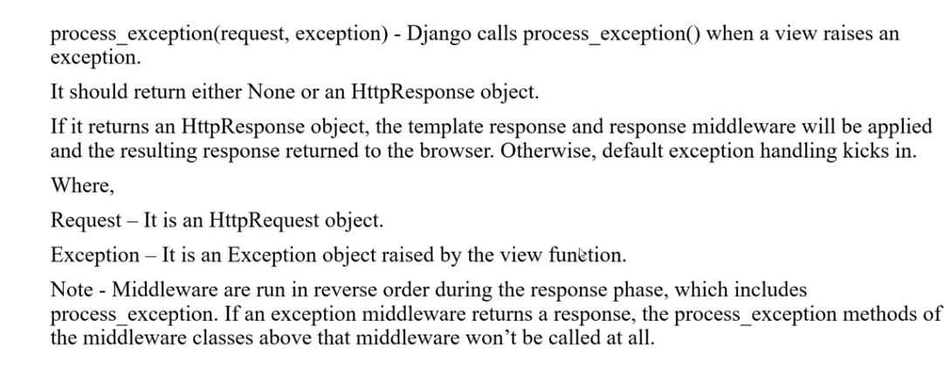

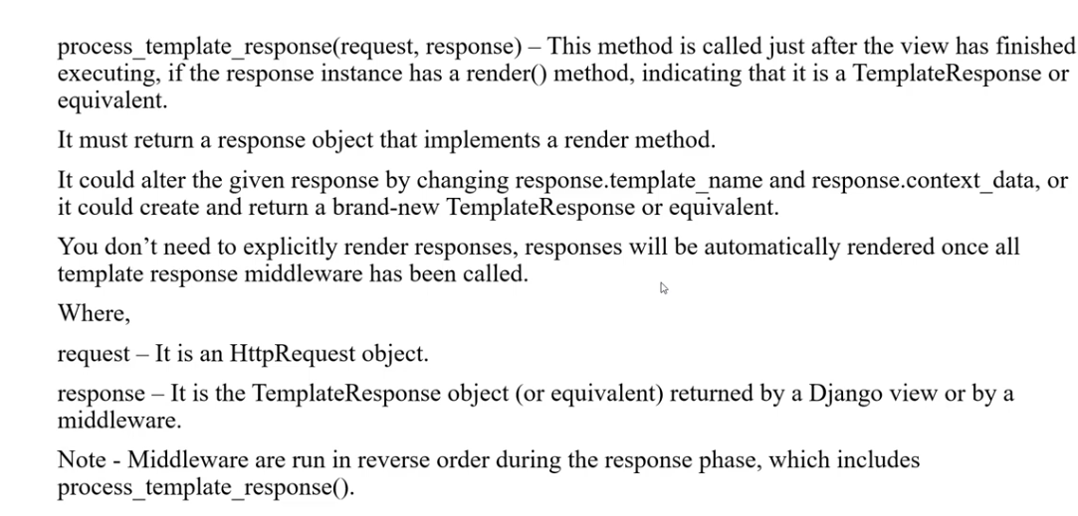
sdafads

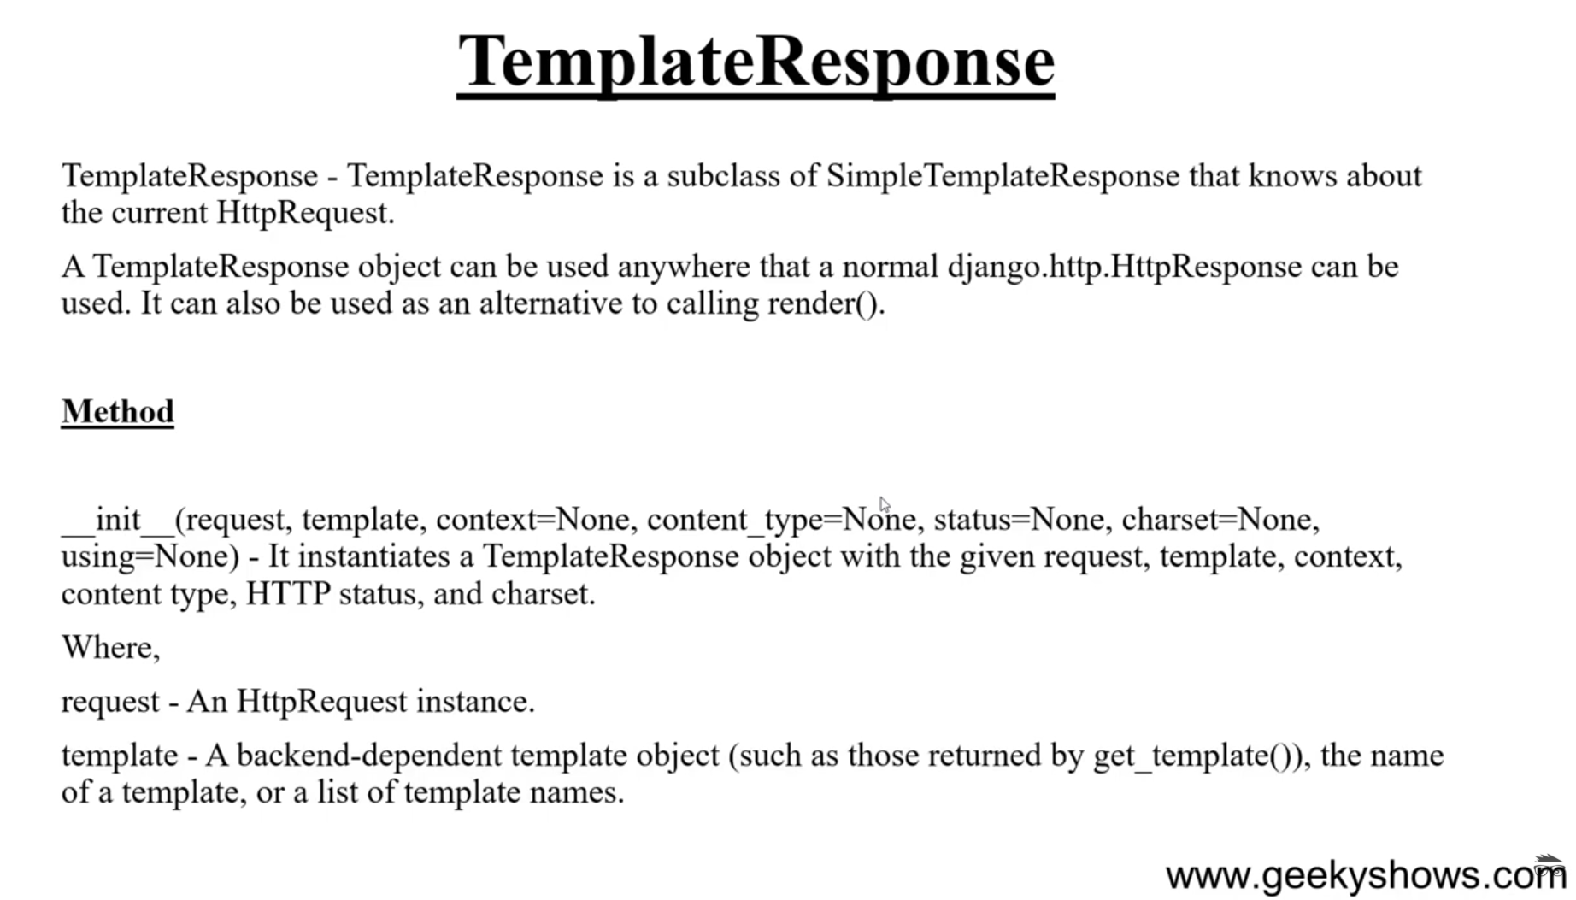
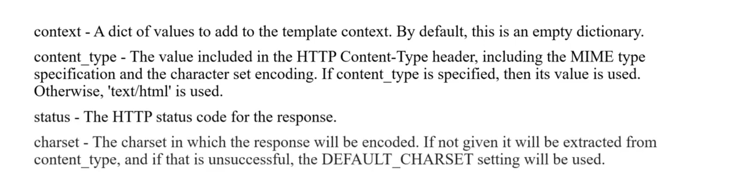

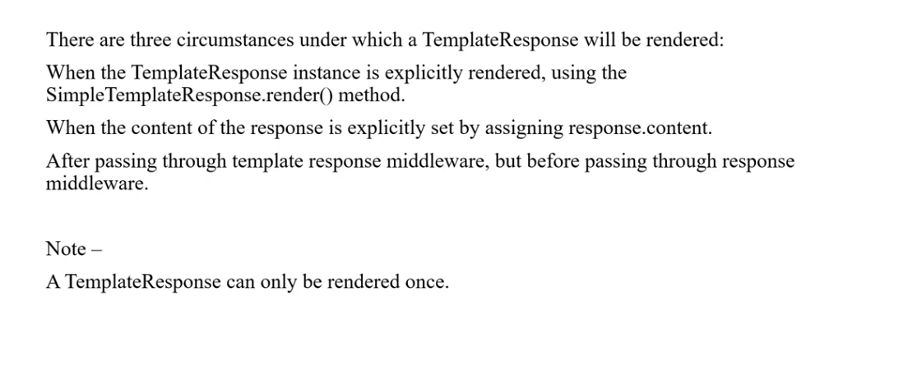
adssd

now one by one we discuss about each hook

a) process_view

from django.http import HttpResponse

class MyProcessMiddleware:
def __init__(self,get_res):
self.get_res=get_res

def __call__(self,request):
response = self.get_res(request)
return response

def process_view(request,*args,**kwargs):
print("This is process View before - view")
return HttpResponse("This is before view")

and if i return None it send command to view and view execute ho jayega
def process_view(request,*args,**kwargs):
print("This is process View before - view")
# return HttpResponse("This is before view")
return None

b) process_exception---> koi exception aayega to chalega ye

class MyExceptionMiddleware:
def __init__(self,get_res):
self.get_res=get_res

def __call__(self,request):
response = self.get_res(request)
return response
def process_exception(self,request,exception):
msg = exception
return HttpResponse(msg)

add this :
def process_exception(self,request,exception):
print("Exception Occured")
msg = exception
class_name = exception.__class__.__name__ // it will give kis class ka error hai ye
print(class_name)
return HttpResponse(msg)

and for it in views.py
def excp(request):
print("i am excp view")
a = 10/0
return HttpResponse("This is excp page")

c)templateresponse
--> basically it is used to modify data that comes from views , before going to template
def __init__(self,get_res):
self.get_res=get_res

def __call__(self,request):
response = self.get_res(request)
return response
def process_template_response(self,request,response):
print("process template response from middleware")
response.context_data['name']='sonam'
return response

views.py

‘def user_info(request):
print("i am info user view")
context = {'name':'Rahul'}
return TemplateResponse(request,'blog/user.html',context)

BUILT IN MIDDLEWARES

READ ABOUT IT IN DOCUMENT

